NRC INSPECTION MANUAL NSIR/DPR
INSPECTION PROCEDURE 71114 ATTACHMENT 04

EMERGENCY ACTION LEVEL AND EMERGENCY PLAN CHANGES

Effective Date: 10/01/2016

PROGRAM APPLICABILITY: 2515 A

71114.04-01 INSPECTION OBJECTIVE

Evaluate the efficacy of changes made to the emergency action level (EAL) scheme and emergency plan to have not reduced the effectiveness of the emergency plan without the U.S. Nuclear Regulatory Commission’s (NRC’s) approval prior to being implemented.

Verify the EAL scheme used by the license is:

- in compliance with 10 CFR 50.47(b)(4) and NRC endorsed guidance or is an approved alternative,

- any changes made to the EAL scheme and or emergency plan do not cause either to no longer meet the requirements of 10 CFR 50.54(q).

In addition, this inspection activity provides monitoring of the effectiveness of the licensee’s program/procedures for implementing the 10 CFR 50.54(q) change process as well as the licensee’s change documentation, i.e., their justification for their 10 CFR 50.54(q) decision. The documentation should be comprehensive enough to allow the inspector to reasonably reach the same conclusion as the licensee.

This inspection verifies aspects of the Emergency Preparedness Cornerstone for which there are no indicators to measure performance.

This inspection procedure may be performed in the office or on site.

71114.04-02 INSPECTION REQUIREMENTS

02.01 Review all licensee EAL changes and EAL basis document changes to determine if any reduced the effectiveness of the EAL scheme.

02.02 Screen all emergency plan changes and select a sample of the changes for review to ensure the changes did not reduce the effectiveness of the emergency plan.

Note: Lower tier documents may also be in the scope of this review if these lower tier documents are controlled by the licensee via 10 CFR 50.54 (q).
02.03 Review 10 CFR 50.54(q) emergency plan change process and practice.

71114.04-03 INSPECTION GUIDANCE

General Guidance

If any emergency plan revision is extensive such that the inspector would expend an inordinate amount of time to complete the review (more than about 20 hours), then the inspector should consider submitting the revision to NRC Headquarters (HQ) Office of Nuclear Security and Incident Response (NSIR) for review.

Note: Licensee submittals, such as license amendments, which have already been identified as requiring NRC approval, should be reviewed by NSIR rather than as an inspection activity under this inspectable area.

Based on the screening, the inspector shall perform an in-depth review of a sample of emergency plan changes which could potentially result in a reduction in effectiveness (RIE). Emergency plan changes implementing risk significant planning standards should be given priority for review. Over the course of a year, the in-depth review effort should include at least one emergency plan change, if any are submitted. In most cases, and all cases involving a risk significant planning standard, determining whether a change is an RIE will require a review of the licensee’s 10 CFR 50.54(q) documentation for the specific emergency plan change.

For any emergency plan change that resulted in a RIE of the emergency plan or the changed emergency plan no longer meets the requirements of 10 CFR 50.47(b) or Appendix E, the inspector shall conduct a further review. If the emergency plan change was implemented without prior NRC approval, the change shall be evaluated in accordance with the guidance in Section IV of the Enforcement Policy (traditional enforcement) and documented accordingly.

10 CFR 50.54(q) requires licensees to (1) follow and maintain the effectiveness of their approved emergency plans, (2) evaluate proposed changes to these plans for their impact on the effectiveness of the plans, and (3) obtain prior NRC approval for changes that would reduce the effectiveness of the plans.

The “emergency plan” is defined as including any document that describes the programmatic methods used by the licensee to maintain preparedness and to respond to an emergency, and to demonstrate compliance with the requirements of Appendix E, and for nuclear power reactors, the planning standards of § 50.47(b).

Note: Lower tier documents may also be in the scope of this review if these lower tier documents are controlled by the licensee via 10 CFR 50.54 (q).

Section 50.54(q)(1)(iv) defines the term “reduction in effectiveness” as a change to the emergency plan that results in a reduction of the licensee’s capability to perform an emergency planning function in the event of a radiological emergency. The phrase “reduction in effectiveness” is an evaluation concept that is used in § 50.54(q) to differentiate between changes that the licensee is allowed to make without prior NRC approval and those that require
prior NRC approval. A determination that a change may result in a RIE does not imply that the licensee could no longer implement its emergency plan and provide adequate measures for the protection of the public. The NRC may approve a proposed emergency plan change that the licensee determined to be a RIE if the NRC can find that the emergency plan, as modified, continues to meet the requirements of Appendix E, and for nuclear power reactor licensees, the planning standards of § 50.47(b), and continues to provide reasonable assurance that adequate protective measures can and will be taken in the event of a radiological emergency.

The licensee’s determination of a RIE is used only to determine whether the licensee has the authority to implement the change without prior NRC approval under § 50.54(q)(3) or must submit for prior NRC approval under § 50.54(q)(4).

A licensee’s emergency plan is part of the licensee’s licensing basis and is approved only for the licensing basis with which it is submitted. If a licensee changes their licensing basis in a fashion that affects the emergency plan, the change must be submitted as a license amendment request and be approved prior to being implemented.

A licensee may revise their emergency plan, EAL scheme and or EAL basis after receiving their NRC Safety Evaluation Review (SER) approval for their emergency plan. Subsequent changes made to the emergency plan, EAL scheme or EAL Basis are required to be compared to the licensee’s latest NRC SER approved emergency plan. A licensee desiring to change its entire emergency action level scheme shall submit an amendment request for its license and receive NRC approval before implementing the change per Appendix E.IV.B.2 of 10 CFR 50.

The requirements of 10 CFR 73.58 “Safety/security interface requirements for nuclear power reactors” also need to be considered for changes made that could potentially have an adverse effect on the safety and security interface, such as implementing changes to plant configurations, facility conditions, or security.

03.01 EAL and EAL Bases Document Change Review.

Licensees normally use an NRC endorsed EAL scheme when submitting their required emergency classification and action level scheme but may propose an acceptable alternative method.

Guidance on acceptable EAL change methodology is contained in RIS 2003-18, “Use of
NEI 99-01, Methodology for Development of Emergency Action Levels,” Revision 4, Dated January 2003,” and its supplements, should be used for changes implemented prior to
February 21, 2012, and may be used for subsequent changes to the extent that it does not conflict with the guidance in Regulatory Guide 1.219. NRC HQ NSIR Division of Preparedness and Response (DPR) assistance may be requested for review and approval of EAL changes which involve a significant portion of the EAL scheme or incorporate an alternative EAL methodology.

Licensees should have an EAL Bases Document. The bases document is considered an integral part of the EALs and should be controlled accordingly. The EAL Bases Document should be readily available for decision makers to clarify the intent of the EAL and provide the necessary context. The EAL basis document should not contain information that modifies the meaning or
intent of the initiating condition (IC) or EAL or give direction for actions beyond those necessary to obtain the IC or EAL threshold values except for those such as dose assessments, chemistry sampling, reactor coolant system leak rate calculation, etc.

When reviewing EAL changes, the inspector should be sensitive to EALs that refer to other documents, such as the security contingency plan, industrial hygiene standards, Offsite Dose Calculation Manual, and manufacturer’s specifications. The referenced documents may be considered sensitive or may not be readily available to the decision makers; however, the information in the EAL Bases Document should contain the information necessary to provide the appropriate context. The inspector should review changes to the EAL and the EAL Bases Document together.

A review of security related EALs or EAL Bases Document changes should be performed to ensure consistency with the Security Contingency Plan. Likewise, a review of the security contingency plan should be performed to ensure consistency with the emergency plan. The inspector should also consult with NRC security specialist inspectors when conducting reviews of security-related EALs and EAL Bases Documents.

- Perform the EAL change review in accordance with Figure 1, “EAL Change Review Flowchart.” The following comments are intended to clarify expectations:

- Administrative changes are considered to be changes made to correct typographical errors or other information other than EAL content.

- Review the licensee’s documentation used to support their 10 CFR 50.54(q) determination. Evaluate this documentation to determine if the licensee’s position is justifiable and appropriate.

- Contact NRC HQ (NSIR/DPR) if it appears that a RIE may have occurred, or when assistance in determining a potential RIE is needed.

- If the licensee made the EAL change(s) due to receipt of a Safety Evaluation Report (SER) or due to NRC direction via advisories, orders, bulletins, etc., review the change and evaluate if the change was made in accordance with the stated NRC guidance or SER.

- Verify that the licensee performed the annual EAL review with State/County authorities in accordance with the requirements of 10 CFR 50, Appendix E, Section IV.B. (may be performed in the office or onsite during the baseline EP inspection) [C1]

03.02 Emergency Plan Change Review.

On occasion, emergency plans undergo extensive changes, (e.g., the combination of multiple emergency plans from different sites) and may be implemented without prior approval if the changes are made in accordance with 10 CFR 50.54(q). If the review of a given change is estimated to take in excess of 20 hours, then the inspector should consider submitting the revision to NRC HQ (NSIR/DPR) for review. The inspector should consult with NRC security specialist inspectors when the emergency plan changes refer to the security contingency plan, including EALs.
Licensees may develop alternative methods for meeting the planning standards and these should be considered for adequacy, however these alternative methods should have been approved by the NRC prior to implementation. If it appears that an emergency plan element is not in compliance with the requirements of 10 CFR 50.47(b), the situation may be a failure to meet a planning standard. Refer to RIS 2005-02 and contact NRC HQ to aid in determining potential RIEs.

Changes selected for review should not be administrative (e.g., typographical corrections). Licensees may develop alternative methods for meeting the planning standards and these should be considered for adequacy, however these alternative methods should have been approved by the NRC prior to implementation.

- Screen all 10 CFR 50.54(q)(5) emergency plan change summary submittals and select a sample of changes to perform an in-depth review of the supporting documentation using Figure 2 as a reference. The sample should consist of:

  - Emergency plan changes implementing risk significant planning standards should be given priority for review.

  - Lower tier documents which contain emergency plan commitments removed from the emergency plan, but must be maintained in accordance with
10 CFR 50.54(q) change process. These lower tier documents shall be administratively tracked by the licensee to ensure the emergency plan integrity and must be available for NRC inspection.

03.03 Review 10 CFR 50.54(q) emergency plan change process and practice.

- Verify individuals responsible for performing the screenings and evaluation understand the intent and procedure steps (i.e., reviews are to be performed against the last emergency plan with an SER).

- Verify screenings and evaluations contain a level of detail appropriate to support the change (i.e., does the screening block for a given planning standard describe more than just “yes” or “no”).

- Review licensee 10 CFR 50.54(q)(3) violations since the last inspection to determine if the violation could or should have been prevented by an appropriate and accurate screening or evaluation and if so has the licensee taken action to correct the issue.

71114.04-04 RESOURCE ESTIMATE

The direct inspection effort for EAL reviews is estimated to be, on average, between 12 hours and 20 hours annually, regardless of the number of reactor units at a site. However, all sites do not submit EAL changes every year. This estimate is based on regional experience in reviewing EAL changes and suggests that each region will expend about 8 hours times the number of sites in the region reviewing EAL changes. This time will be spent on the few sites that submit EAL changes, but should average out to the estimate provided.
The direct inspection effort for emergency plan reviews is estimated to be, on average, between 12 hours and 20 hours annually, regardless of the number of reactor units at a site.

71114.04-05 PROCEDURE COMPLETION

The emergency plan change reviews and screenings should be documented in an inspection report in accordance with Inspection Manual Chapter 0612. Performance of this inspection procedure’s change review or screening does not constitute approval of the affected emergency plan changes. Sample documentation wording for EAL and emergency plan changes with no apparent RIE is as follows:

“Since the last NRC inspection of this program area, Emergency Plan Revision(s) XX to XX were implemented based on your determination, in accordance with 10 CFR 50.54(q), that the changes resulted in no reduction in effectiveness of the emergency plan, and that the revised emergency plan as changed continues to meet the requirements of 10 CFR 50.47(b) and requirements of Appendix E to 10 CFR 50. The inspectors conducted a {(1) sampling review of the emergency plan changes, and/or (2) review of EAL changes} to evaluate for potential reductions in effectiveness of the emergency plan. However, this review does not constitute formal NRC approval of the changes. Therefore, these changes remain subject to future NRC inspection in their entirety.”

This procedure is considered complete when all the inspection requirements listed in the procedure have been satisfied. Routine reviews of problem identification and resolution activities performed in this attachment should equate to approximately 10 to 15 percent of the resource estimate range described above. For the purpose of reporting completion in the Reactor Program System (RPS), the sample size is defined as 1. A sample size of 1 will be reported in RPS when the procedure is completed in its entirety.

71114.04-06 REFERENCES

Regulatory Guide 1.219, “Guidance on Making Changes to Emergency Plans For Nuclear Power Reactors”

Regulatory Issue Summary 2005-02, “Clarifying the Process for Making Emergency Plan Changes,” February 14, 2005

RIS 2003-18, “Use of NEI 99-01, ‘Methodology for Development of Emergency Action Levels,’ Revision 4, Dated January 2003,” and supplements

END

Figure 1 EAL Change Review Flowchart
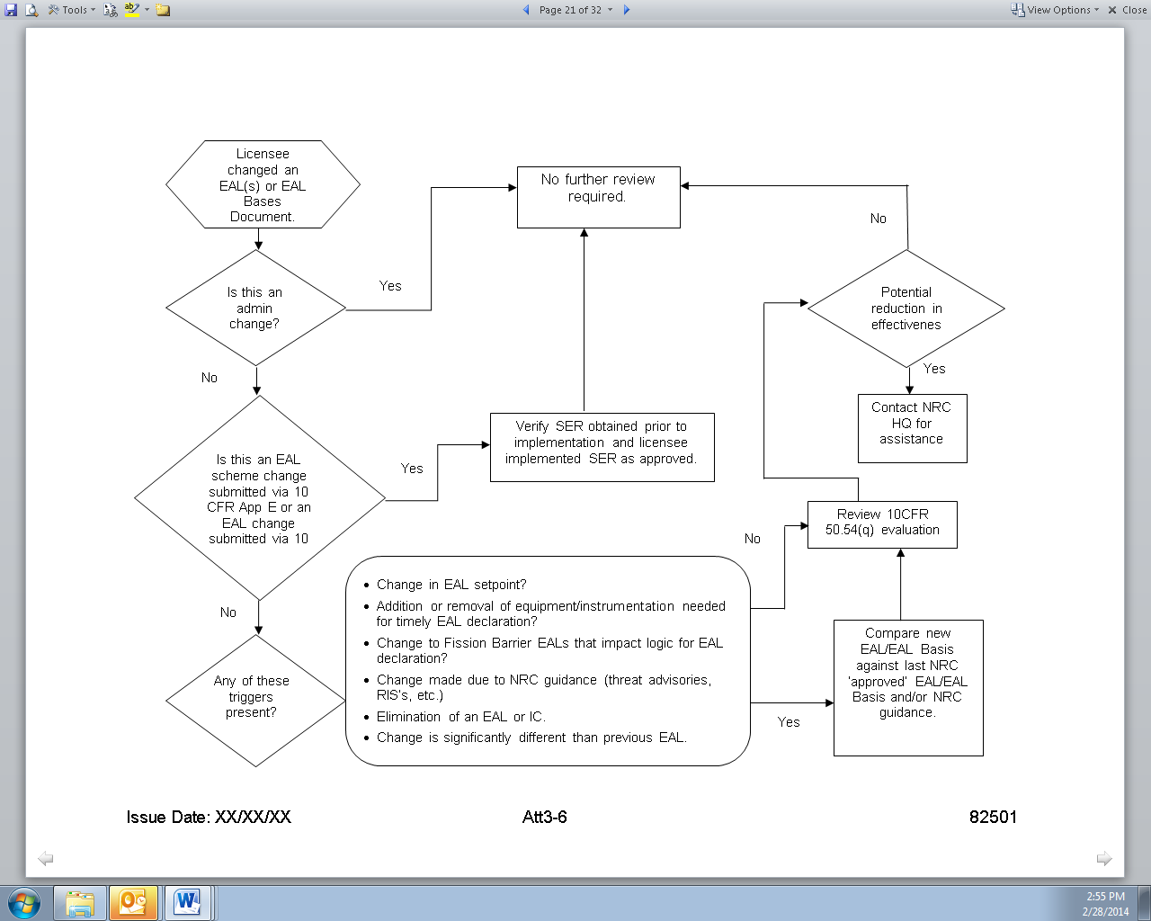
Figure 2: Emergency Plan Review Flowchart

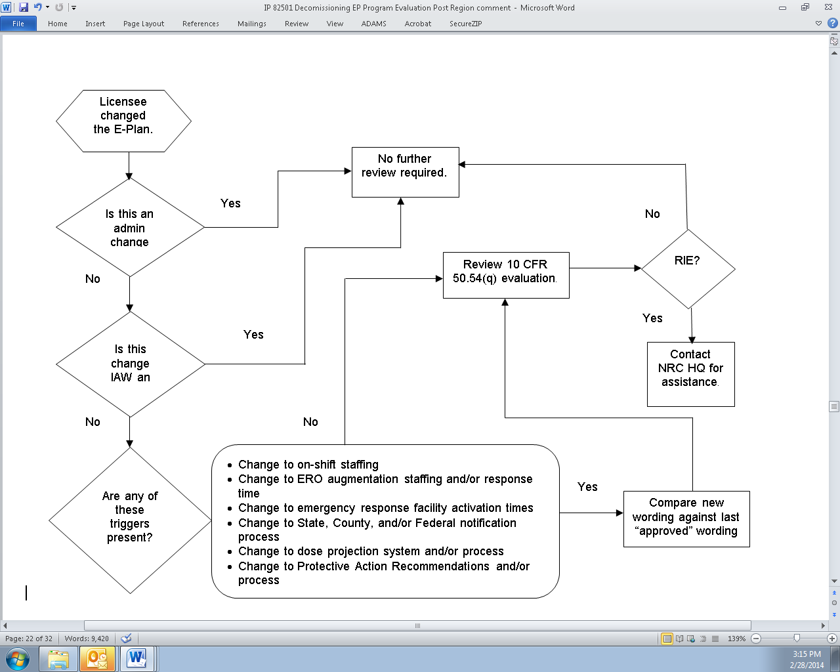

Attachment 1- Revision History for IP 71114.04
Commitment Tracking Number | Accession Number  Issue Date Change Notice | Description of Change | Description of Training Required and Completion Date | Comment and Feedback Resolution Accession Number (Pre-Decisional, Non-Public Information)
N/A | 10/25/06 | Completed four-year historical CN search. | N/A | N/A
C1 | 09/09/01 | Revised to add previously deleted inspection requirement considered necessary for the baseline inspection program.  Reference is Davis-Besse Lessons Learned Task Force Item No. 3.3.4.7. (this commitment was confirmed to be still in effect, as of 9/24/08) | N/A | N/A
 | 10/25/06  CN 06-029 | Complete rewrite of document structure to align it with RIS 2005-02 concerning the correct process for making Emergency Plan changes with two clarifying flowcharts (Figures 1 & 2), addition to meet one commitment. | N/A | ML061790125
10/31/08  CN 08-031 | N/A | Revision to incorporate a review of security-related Emergency Action Levels and Emergency Plan changes | No | ML081640372

Commitment Tracking Number | Accession Number  Issue Date Change Notice | Description of Change | Description of Training Required and Completion Date | Comment and Feedback Resolution Accession Number (Pre-Decisional, Non-Public Information)
 | ML15245A748  07/21/16  CN 16-017 | Editorial changes:  - Removed “Inspection Bases” and “Level or Effort” and added “Inspection Objective” in accordance with IMC 0040 “Preparing, Revising and Issuing Documents for the NRC Inspection Manual” formatting expectations.  - Change “decrease in effectiveness” to “reduction in effectiveness” and corresponding DIE to RIE  - Align procedure with standard section numbering format of completion section under 711XX.XX-05 and the references under 711XX.XX-06 (see ROP Feedback Form 71114-1925)  Added statement “This inspection procedure may be performed in the office or on site” to the inspection objective section.  Added Inspection requirement 02.03 Review 10 CFR 50.54(q) emergency plan change process and practice and guidance step 03.03 from IP 71114.05 to this IP.  Updated 10 CFR 50.54(q) description in accordance with new EP rule effective December 2011 | None | Comment Resolution – ML15245A773  Feedback Form – 71114.04-1925 ML15245A742

Commitment Tracking Number | Accession Number  Issue Date Change Notice | Description of Change | Description of Training Required and Completion Date | Comment and Feedback Resolution Accession Number (Pre-Decisional, Non-Public Information)
Added 10 CFR 50 Appendix E.IV.B guidance for a licensee desiring to change its entire EAL scheme would require prior NRC approval before implementing the change and that less substantial EAL changes may be made using the § 50.54(q) process.
Added description of 10 CFR 73.58 “Safety/security interface requirements for nuclear power reactors”
Inspection Guidance step 03.01, replaced EAL scheme references with NRC endorsed schemes.
Deleted step 03.02.b – Skill of the craft
Added section 71114.04-06 “References”
Inconsistent use of the term “emergency response plan” and “emergency plan” changed to “emergency plan.”
Move documents referenced within the procedure to the “references” section.
Added 02.03 “Review 10 CFR 50.54(q) plan change process and practice” moved in from IP 71114.05.
“General Guidance” Page 3
- 2 paragraph change to “which with it is submitted.”

Commitment Tracking Number | Accession Number  Issue Date Change Notice | Description of Change | Description of Training Required and Completion Date | Comment and Feedback Resolution Accession Number (Pre-Decisional, Non-Public Information)
- 4th paragraph last sentence “A licensee desiring to change its entire emergency action level scheme shall submit an amendment request for its license and receive NRC approval before implementing the change per Appendix E.IV.B.2 of 10 CFR 50.”
03.01 ”EAL and EAL Bases Document Change Review”
- Change 4th paragraph to read “, and manufacturer’s specifications.
- added “together” to the 2nd to last paragraph last sentence “The inspector should review changes to the EAL and the EAL Bases Document together”
03.02 “Emergency Plan Change Review,” removed specifics about how to handle enforcement and documentation of.

Added References section 71114.06

Added to section 71114.04-05 “Procedure Completion” the IP 71152 “Problem Identification and Resolution” expectation for routine PI&R activity reviews to be approximately 10 to 15 percent of the baseline cornerstone inspection procedure resources estimates. The 10 to 15 percent approximation is based on the overall expected inspection effort and is a general estimate only.

